NWCSI/Alta Vista August Event 2014

CELEBRATING and CONNECTING
to sustain our collective efforts to promote student growth

School teams across the region are invited to come together as a larger professional learning community to explore
- how regular, public recognition helps us “to know again” our common purpose and sustain our collective efforts to promote student growth
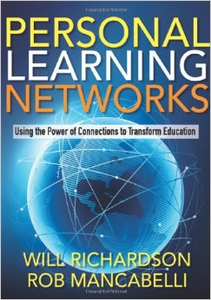
- how connecting online and offline with other educators can provide just-in-time professional learning

Participants will have the opportunity to
- practice celebrations that grow and strengthen learning-focused collaborative cultures
- learn how to use online tools to create their own personal learning networks
- connect face-to-face with other educators in the room

Kaelyn Bullock, high school social studies teacher from Shoreline Christian School, will share how becoming a connected educator has impacted student learning in her classrooms. See her blog post at http://collaboratingforlearning.wordpress.com/category/educational-technology-2/
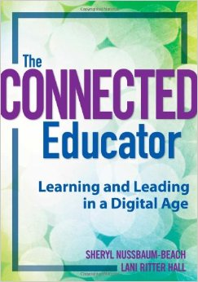
Other connected educators in the room will also have the opportunity to share their experiences. Participants are encouraged to bring devices to connect to the internet.

Pre-registered participants will have the opportunity to shape our efforts to connect by responding to the question - With whom or over what do you want to connect?

Participating schools will receive copies of Personal Learning NetWorks by Will Richardson and Rob Mancabel and The Connected Educator by Sheryl Nussbaum-Beach.

When: August 19, 2014; check in & coffee at 8:30, workshop - 9:00-2:30
Where: Mount Vernon Christian High School
Cost: $40 per participant; continental breakfast and lunch provided
Clock Hours: 5 WA State Clock Hours available
RSVP: Elaine Brouwer - avcelaine@comcast.net
The purpose of the August Event is to stimulate and facilitate a cross-Region discussion of how to fulfill our mission as Christian schools. While a special invitation is extended to administrators and teachers new to our Regional schools, we encourage schools to send a team to carry the conversation back to their learning communities.

