Opening Doors to Student Understanding Using
Essential Questions and Curriculum Mapping

NWCSI/Alta Vista August Event 2013
August 20, 2013, Mount Vernon Christian High School
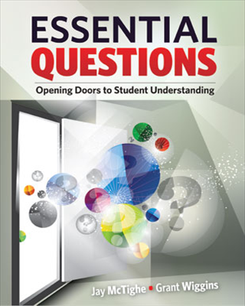
A strong curriculum is the foundation for strong, mission-focused teaching and learning.

School teams across the region are invited to come together as a larger professional learning community to explore how to design and use essential questions and curriculum mapping to facilitate student understanding. The day will be organized around two essential questions:

What’s so essential about Essential Questions?

If curriculum mapping is the answer, what is the question?
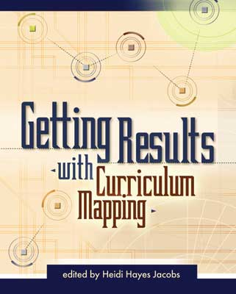
Participants are encouraged to bring samples of their essential questions and curriculum maps to use in working sessions.

At the conclusion of our time together, we will discuss how to continue to work together given that most of our schools are focusing on essential questions and are mapping their curriculum using the same online tool.

Participating schools will receive 2 copies of Essential Questions: opening doors to student understanding by Jay McTighe and Grant Wiggins.

When: August 20, 2013; registration & coffee at 8:30, workshop - 9:00-2:30
Where: Mount Vernon Christian High School
Cost: $40 per participant; continental breakfast and lunch provided
Clock Hours: 5 WA State Clock Hours available
RSVP: Elaine Brouwer - avcelaine@comcast.net
The purpose of the August Event is to stimulate and facilitate a cross-Region discussion of how to fulfill our mission as Christian schools. While a special invitation is extended to administrators and teachers new to our Regional schools, we encourage schools to send a team to carry the conversation back to their learning communities.

